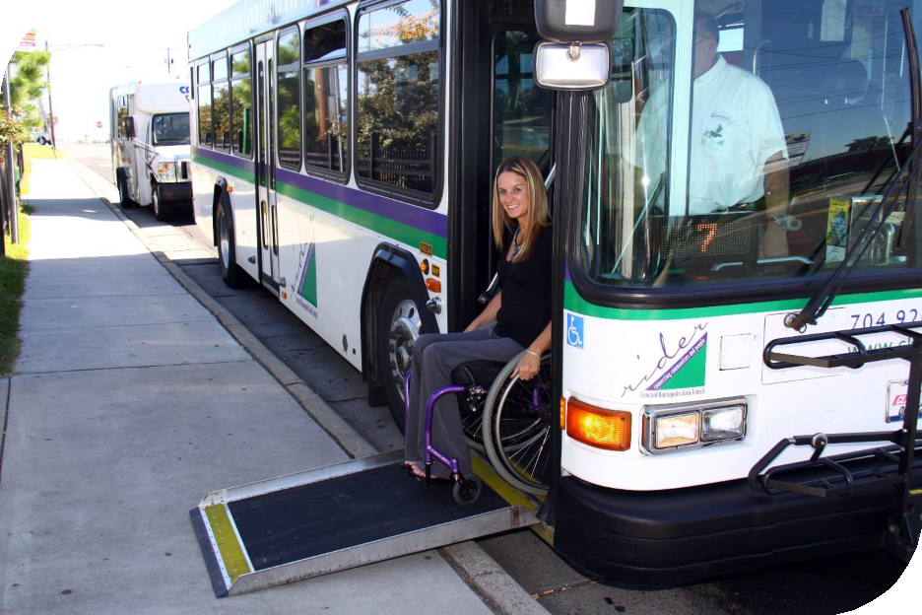
Rider Transit ADA Paratransit
How to Ride Guide

ADA Paratransit Program Policies and Procedures for Passengers & Staff

A partnership of Concord Kannapolis Area Transit

Mobility for all

Transportation is a critical part of everyday life. Whether someone needs to get to work, school, medical appointments, shopping, recreation or social opportunities, public transit is a great option available to everyone in our communities to help get them where they need to go. Using fixed route (bus) public transit can be challenging or impossible for some people with disabilities. This guide has been prepared to help explain the accessibility options available on Rider Transit and to explain how use our ADA Paratransit program.

Rider Transit buses are ADA accessible

All Rider buses have curb level entry and can be lowered to make boarding easier, have a fold out ramp that can be used to make getting on the bus easier, and are equipped with two locations on each bus to accommodate and secure wheelchairs and other mobility devices. For safety reasons, all wheelchairs and other mobility devices must be secured while being transported. Audio and visual (LED text display) announcements are made of each stop along each route. Priority Seating is available for persons with disabilities as well as senior citizens. Service animals are allowed to accompany passengers with disabilities. A service animal is any animal trained to work or perform tasks for an individual with a disability, including but not limited to: guiding individuals with impaired vision, alerting individuals with impaired hearing to intruders or sounds, providing minimal protection or rescue work, pulling a wheelchair, or fetching dropped items.

Rider Transit offers a low-cost, “origin to destination”, curb to curb ADA accessible Paratransit vehicle ride sharing service (drivers will assist riders from door to door as needed), to help meet the needs of mobility impaired residents in our area that find it difficult or impossible to use and/or navigate the fixed route bus service. “Shared-ride” means passengers may travel with more than one passenger with different destinations and/or origins.

Americans with Disabilities Act (ADA) & Paratransit Services

The Americans with Disabilities Act of 1990 (ADA) is a civil rights bill designed to remove the physical and attitudinal barriers that have kept persons with disabilities from fully participating in American society. The ADA states that Rider Transit’s fixed route bus system should be the primary means of public transportation for everyone including people with disabilities. ADA regulations require transportation providers who operate a fixed-route system to offer complementary Paratransit services to eligible individuals in an area defined by corridors ¾ of a mile on either side of the fixed route, with no restrictions on trip purpose. Anyone wishing to use the Paratransit service must complete an application to determine eligibility. A passenger may be determined eligible once the application and functional assessment review processes are completed. If an applicant is determined eligible for this program one of three designations may be made:

- Unconditional (permanent)
- Conditional (Some trips are eligible on Rider's ADA Paratransit and others must be used on Rider Transit’s fixed route buses)
- Temporary (Can only use the service a certain period of time during expected duration of the illness or condition)

Each certified Paratransit passenger will receive an Eligibility Determination Letter with a certification expiration date. This letter will include one of the three eligibility determinations, and the Rider Transit ADA Paratransit How to Ride Guide. If you would like to see if you qualify for the Paratransit System please give Rider Transit a call at 704.920.5876.

What are the service hours for ADA Paratransit service?

The Rider Transit ADA Paratransit service is offered during the same days and hours the Rider Transit fixed-route system is in operation – Monday-Friday from 5:30am to 8:30pm, and Saturday and Sunday from 8:30am to 8:30pm. There is no Rider Transit or ADA Paratransit service on the following holidays:

New Year’s Day Memorial Day July 4th
Labor Day Thanksgiving Day Christmas Day

What is the service area for ADA Paratransit trips?

Rider Transit provides complementary Paratransit service to origins and destinations within corridors with a width of three-fourths of a mile on each side of each Rider Transit bus route. You don’t have to live within ¾ of a mile of a Rider Transit bus route to qualify for ADA Paratransit service. As long as there is Rider Transit bus service within ¾ of mile away from where you are traveling to and from, Rider Transit ADA Paratransit service is available.

How much does an ADA Paratransit trip cost?

Federal regulations allow the fare for ADA Paratransit to be as much as twice the cost of riding the fixed- route bus service. Currently the cost to ride on Rider Transit’s ADA Paratransit is $2.00 each way (the regular Rider Transit fare is $1.25).

What is the application procedure for ADA Paratransit services?

To begin the application process, you will need to contact Rider Transit at (704) 920-5876 to request an ADA Paratransit application. Once the application is complete, we will submit a healthcare form to your physician for completion. Next, you will be asked to participate in an ADA Paratransit Service Eligibility Determination evaluation interview and functional assessment.

You will notified of your eligibility in writing within 21 days after your assessment. If you have questions or have not been contacted within 21 days of submitting your application, please call Rider Transit at 704.920.5876. If an eligibility determination has not been reached after 21 days, you will be temporarily able to use Rider Transit’s ADA Paratransit service until a final eligibility determination has been made.

If you are eligible for Rider Transit’s ADA Paratransit services you will receive a certification letter and a Rider Transit ADA Paratransit How to Ride Guide with information about how to use the service. If it is determined that you are not eligible, you will receive information on the appeal process.

Application Denial Appeal Process

If your application for ADA Paratransit services is denied and you wish reconsideration of this decision, you may appeal the decision through the following process:
- A request of appeal must be filed with Rider Transit within 60 days of the notice in ineligibility.
- At the time Rider Transit receives a written appeal to a decision, a hearing will be set up to allow the applicant the opportunity to state his/her case.
- A determination from the Appeals Committee must be handed down within 20 days of the hearing. If not, the individual may use the services until such time as final determination is made.
- There will be a total of 5 Panel Members for the Application Appeals Process. One member will be a consumer (Consisting of 1 Active Paratransit Rider). The remaining Appeals Committee members will be comprised of a Rider Transit staff member, a medical professional, and two representatives from local service agencies.
- If, once the Appeals Committee determination is made, the individual still feels that there has been an error; a written request may be made within twenty-one (21) days for a hearing with the Rider Transit Manager. A written determination from the Rider Transit Manager will be handed down within 20 days of the hearing. This determination is final.
- All communications for appeal must be in writing.

Visitors & ADA Paratransit Services

If you are visiting Concord & Kannapolis and you present documentation that you are ADA Paratransit eligible in your home jurisdiction Rider Transit will provide ADA Paratransit service to you while you are here for up to 21 days per year; that is per 365-day period from the first day of use. The 21-day limit includes consecutive days, or days parceled out over several shorter visits. Visitors that do not have documentation of ADA Paratransit eligibility must provide documentation of residence and if not apparent, documentation of their disability.

Reservations - How do I schedule a trip?

The Rider Transit ADA Paratransit program provides “next day” service, meaning transportation requests must be made the day prior to the trip. Service must be scheduled no later than one (1) day prior to service date but may be scheduled up to sixty (60) days in advance. To schedule a trip, please follow the steps and contact Rider ADA Paratransit Reservationist @ 704-920-5858.

Scheduling window

Pick up times for trips will be scheduled within a window of up to one hour before or after the time you request a trip, as negotiated between passengers and Rider ADA Paratransit. The example below illustrates a requested time for pick up and some potential actual scheduled pick up times:

Initial Passenger pick up request time: 10:00am

Examples of possible final negotiated pick up times: 9:00am (earliest), 10:00am, 11:00am (latest)

If a passenger has a latest arrival time (such as a doctor’s appointment), or an earliest departure time (such as when a work shifts ends), then the negotiated pick up time would be an hour prior to arrival or an hour after departure. If your schedule requires that you arrive by a certain time at your destination, or that you cannot leave earlier than a certain time, please let us know when scheduling your ride so that we can accommodate your needs.

The example below illustrates a requested time for pick up for a passenger that works until 5:00pm and some potential actual schedule pick up times:

Initial Passenger pick up request time: 5:15pm

Examples of possible final negotiated pick up times: 5:15pm (earliest), 5:45pm, 6:15pm (latest)

Pick up window

Once your pick up time has been established, Rider ADA Paratransit will arrive within 15 minutes before and up to 15 minutes after your scheduled pick up time, so please be ready to go anytime within that window. Once the Rider ADA Paratransit vehicle arrives and is within that window, they will wait up to 5 minutes for you. If you are not ready to go within that time, the vehicle will depart and the trip will be noted as a No Show. Please see the example below:

Scheduled pick up time: 2:00pm

Pick up window when the vehicle may arrive to pick you up: 1:45pm to 2:15pm.

You must purchase a ticket book prior to your first scheduled trip. You can purchase your ticket book by contacting Rider ADA Paratransit at (704) 920-7433. To schedule a trip within the service area, please contact Rider ADA Paratransit Reservationist at (704)-920-5858 during our regular business hours (Monday –Friday, 8am-5pm, Saturday & Sunday 8:30am-5pm) to make trip arrangements. If you have previously scheduled a trip and no longer need the scheduled trip, you must call (704)-920-5858 at least 90 minutes prior to the scheduled pick up to cancel.

Personal Care Assistants & Guests

A Personal Care Assistant (PCA) is someone designated or employed specifically to assist the passenger in meeting their needs. The PCA can ride at no cost and must have the same origin and destination as the passenger. Space for a PCA must be reserved at the same time the passenger reserves his/her ride. Passengers are allowed to travel with at least one companion, such as a friend or relative, in addition to a PCA. The fare for the companion is the same as the fare for the passenger. Additional companions accompanying the passenger will be allowed on a space available basis only. Passengers must reserve a space for the companion when they reserve their ride. The companion must have the same trip origin and destination as the passenger.

No Show Policy

“No shows” – cancelling at the last minute, refusing a ride when the vehicle gets to the pickup location, or failing to appear at the pick location can adversely affect the schedule of Rider ADA Paratransit services and other passengers. If a client fails to notify Rider ADA Paratransit that they will not require transportation service for their scheduled appointment and a vehicle has been dispatched for the individual, the client will receive a “No Show.”

Any scheduled trips that result in the following conditions are considered as “No Shows”.

- CL-Late Cancellation – Passenger cancels less than one (1) hour and 30 minutes before pick-up time.
- CD- Cancel at Door – Passenger calls and/or vehicle is in front of client’s door.
- NS- No Show – Van was at the pick-up location and passenger was not there.

If a passenger “no-shows” 10% or more of their scheduled trips in a rolling 30 day period and/or 3 or more trips within a rolling 30 day period, the passenger will receive a notification letter warning of the infractions. If a passenger “no-shows” 10% or more of their scheduled trips and/or 3 or more trips within another 30- day period in a quarterly time frame (i.e., January – March, April – June, July – September, October - December), the passenger will be notified in writing of the individual dates and notes regarding “no shows” and that they have been suspended, along with information on how to appeal the suspension, and the information will be documented in the passenger’s file.

A first time suspension means that a passenger will not be able to schedule or receive trips on Rider Paratransit for one (1) week. If a passenger receives 10% with a minimum of 3 or more “no-shows” within a 30-day period, but does not receive any more “no-shows” within that quarterly time frame, the “no-shows” will be removed from the passenger’s record. If a passenger continues a pattern of “no-shows” as outlined above, additional, longer suspensions of service (2nd offense, 2 weeks, 3rd offense, 1 month) may be imposed.

Additionally, if a passenger “no-shows” on their outbound trip (i.e. from residence), Rider ADA Paratransit will not cancel out the inbound trip (i.e. from destination); unless our reservations (Mobility Management Department) is notified by the passenger. Each leg of a trip will be treated as a separate trip.

No Show & Suspension Appeal Policy

A customer (or a customer's representative) may file a written appeal for an individual no show or suspension issued by contacting Rider ADA Paratransit in writing within fourteen calendar days (14) of receipt of the notice of “no show” and/or suspension.
Rider ADA Paratransit staff will review the information provided by the customer (or the customer's representative) and make a decision to either uphold the individual no show or to excuse it within ten (10) business days of receipt of written appeal.

If the No Shows have accumulated to a point where a suspension will be activated, the customer (or the customer's representative) may file a written appeal for a review of all No Shows by contacting Rider ADA Paratransit (the 3 suspension Appeal Panel Members will be members of the Suspension Appeals Panel, including an active Paratransit user). If a decision has not been made within (10) business days the customer will be allowed to ride until a decision has been rendered.

If the customer is not satisfied with the review by Rider ADA Paratransit, they may request in writing a formal review by the Rider Transit Manager. A review will be scheduled and a decision made within twenty one (21) days of receiving the written request.

No Strand Policy

If we provide Paratransit transportation for a passenger to a destination, and for some reason the return trip results in a no-show, Rider ADA Paratransit will not leave a passenger stranded even if the passenger no-shows on the return trip. When Rider ADA Paratransit returns to pick up the passenger, the no-show will remain on their record. Return service will be provided as soon as possible, without a guaranteed window time.

Complaint/Compliment Procedure

Rider Transit welcomes feedback, both positive and constructive, regarding our ADA Paratransit services. Any person who believes they have been subjected to discrimination or received inadequate customer service while using the Rider Transit/ADA Paratransit service may file a complaint with Rider Transit. A complaint must be filed no later than 5 business days after the date of the incident. All complaints must be filed at the Rider Transit Center or by phone to a Rider Transit Customer Service Representative (CSR) at 704.920.7433, or you prefer to make a compliment or file a complaint electronically, you may contact via our web comment form at http://www.ckrider.com/Contact.aspx. Letters may be sent to the following address:

Rider Transit Center
Attn: ADA Coordinator
45 Transit Ct NW
Concord, NC 28025

We ask that have the following information available and supplied when filing a compliment or making a complaint:

  - Name, address, and contact number
  - Detailed description of customer complaint/compliment (i.e., van late, rude telephone operator, van operator provided excellent customer service, reservationist was very polite)
  - Date & time of incident
  - Vehicle identification
  - Location of incident
  - Call back desired

Comments/complaints are reviewed by the manager(s) responsible for the department to which the complaint or compliment is directed. The incident will be investigated by the appropriate personnel who will document the investigation. The investigation should take no longer than 5 business days; however, depending on the incident, a longer period of time may be warranted. If a longer period of time is needed, Rider ADA Paratransit staff will advise the complainant regarding the delay. Once the investigation has been completed, Rider staff will follow-up via telephone call and/or email.

